Animal Welfare Week
IVSA Berlin

We decided to have one activity each day which we posted about on our facebook page. Here we go!
First Day of #ivsaAnimalWelfareWeek
IVSA Thessaloniki supports animal welfare in Berlin.
Learning about surgical sutures and having some practical exercises on skin made of silicone was one of our activities during our exchange with 13 members of IVSA Thessaloniki. A good opportunity to improve your skills before the serious side of life begins.
We all know that the stressful environment during surgery makes it even harder for beginners to learn and work quick enough to manage a short anasthesia for the patient.
Those skins and other equipment with professional explanations are offered 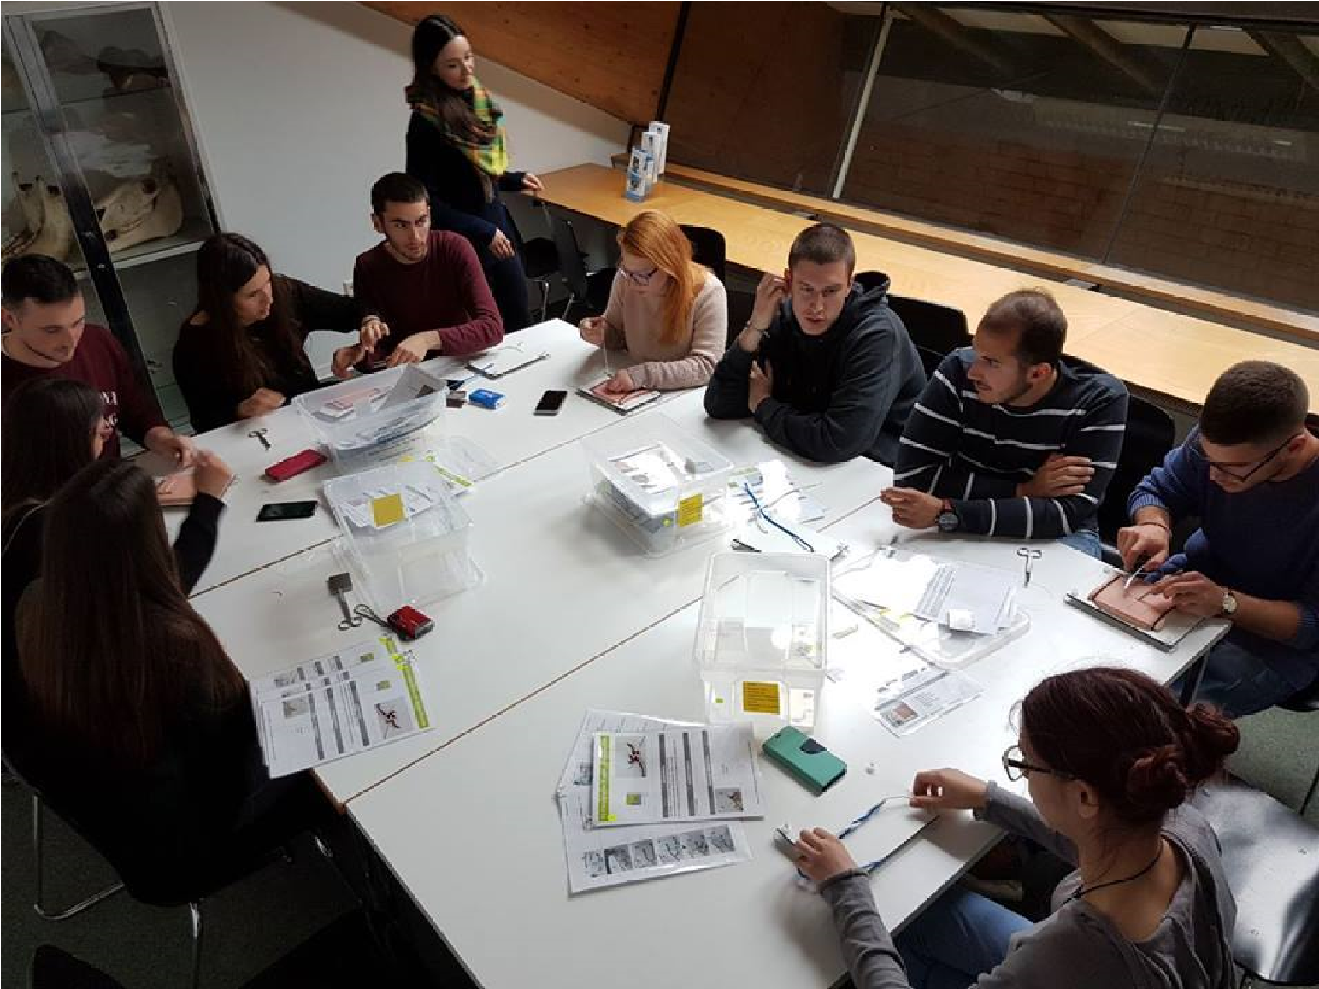about an hour to study on your own. =) Second day #ivsaanimalwelfareweek
to be rent for free by

Vet Skills Ne
t
in our university and you can use them for
We have had a great discussion about breeds and hazards of breeding. But as well about opportunities how to undo the mistakes made in the past. Have you ever heard about the "Retromops"? http://animalwelfarists.tumblr.com/…/fuglydog-retromops-pug… https://retrieverman.net/2015/01/29/saving-pug-from-a-lifetime-of-misery/
3rd day of #ivsaanimalwelfareweek
Today we were visiting the Zoo Berlin with our exchange students from Thessaloniki.
We talked with the zoo vet about the role of zoos in wild animal protection and why breeding programs can help to maintain a population - and also we learnt that other species , e.g. hippos are so reproductice that they need contraceptives to not over-reproduce!
Have you ever seen the Hippo pill? Have a closer look what the vet is holding in his hand!
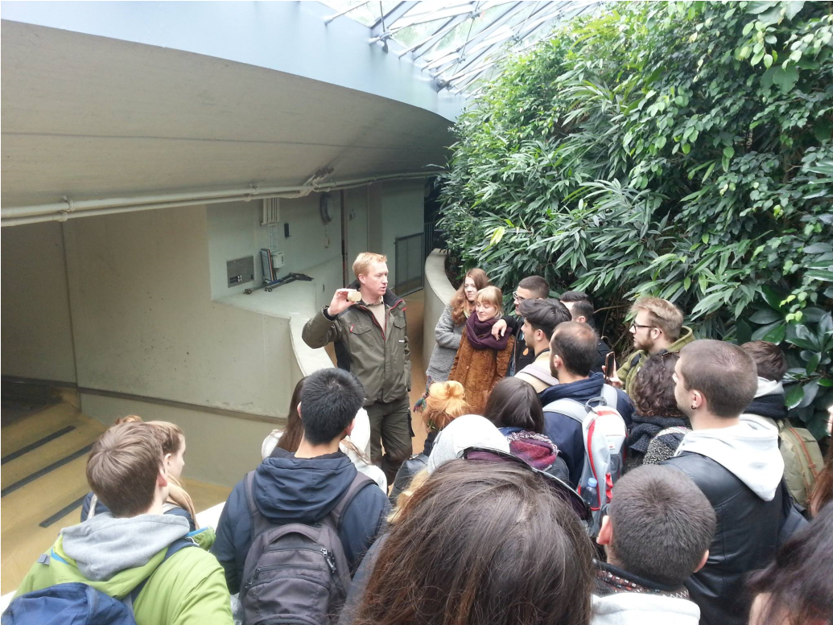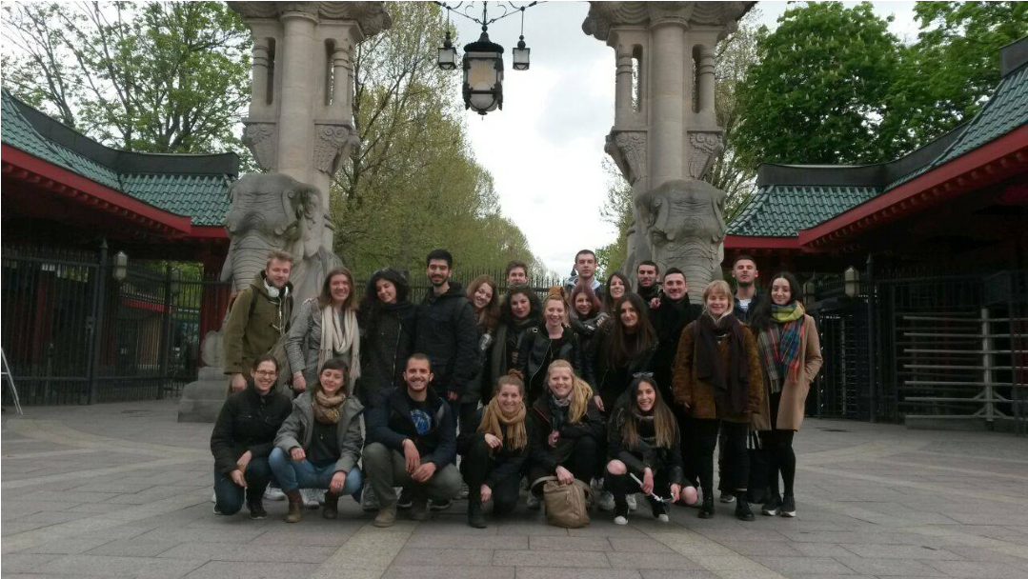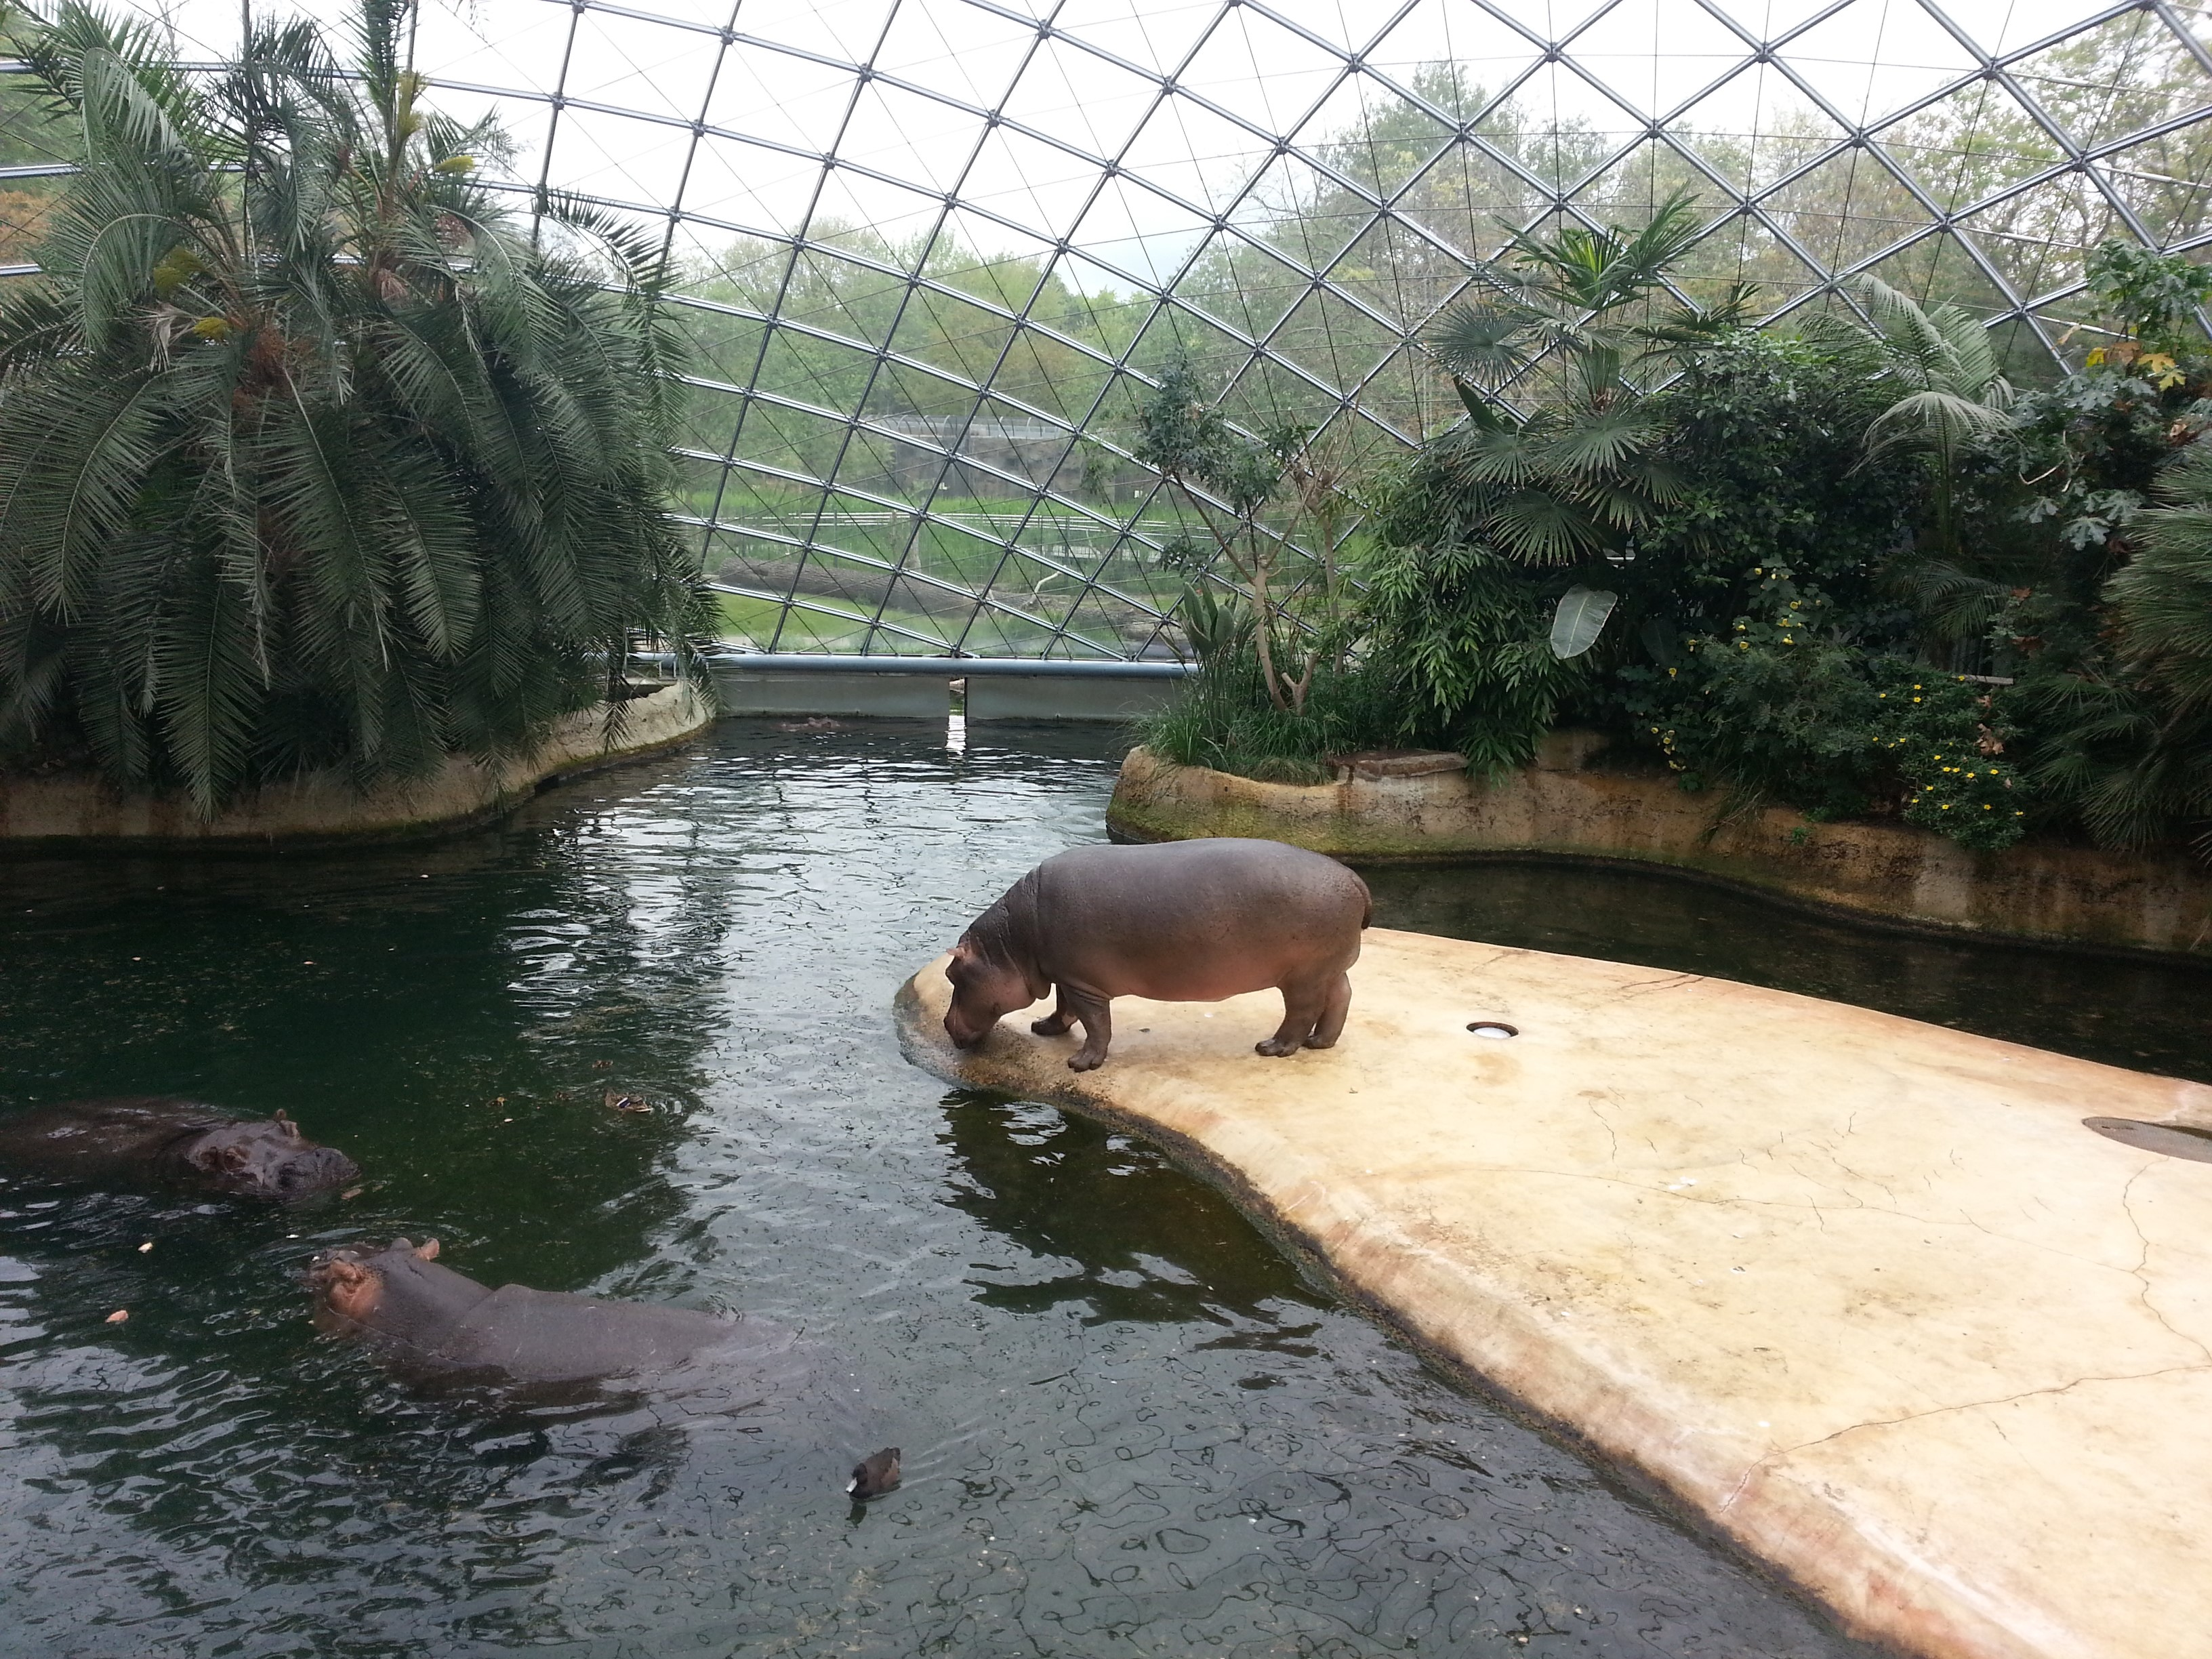
Day 4 #Ivsaanimalwelfareweek
We are getting closer and closer to our opening of the new exhibition about animal welfare. In total there have been 10 students writing some articles, posters, poems about animal welfare. Thanks to our lovely library we have the great oppertunity to present those works in the first floor at the open space.
I will upload some pictures in future!
As it seems now, we will be able to open the exhibition just next week! We collected about 12 articles/essays/papers written by students which are all about animal welfare. Subjects vary from Bee keeping to Slaughterhouses!
Day 5 #ivsaanimalwelfareweek
Today was all about wild animals in Germany.
We ordered a huge carton of info material from "nabu Germany" which is an animal protection association aiming to raise awareness about wild animals in Germany and other environmental issues.
We talked about local bird species, how to become a "bat protector", the relation between horse and human and also about the returning of the wolfs to Germany!
