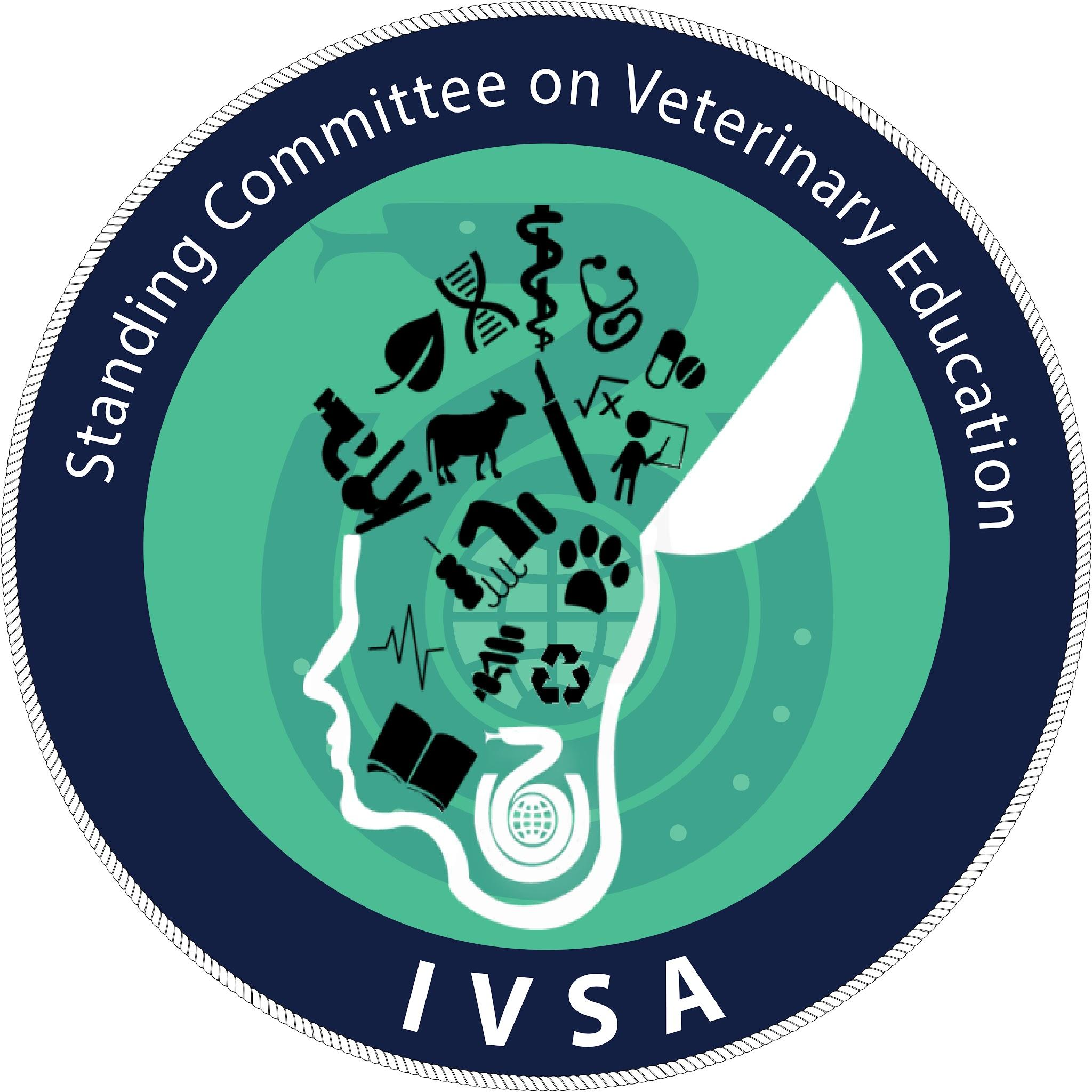

Manual for SCoVE Ambassadors

Detailed instructions (guideline and administration) can be found here.

Introduction
The SCoVE Ambassadors are IVSA members around the world that will serve as the bridge between the SCoVE committee, Vetstream, and the Ambassadors’ local faculty and its students. In this manual, you will find everything you will need to earn points, promote projects, and discover the various opportunities and experience in being a part of the SCoVE Ambassador Network!

Who is behind the SCoVE Ambassadors?
A team of dedicated veterinary students from IVSA SCoVE with the sponsorship from Vetstream spells the formula for a global network of student ambassadors!

Introduction to SCoVE
The IVSA Standing Committee on Veterinary Education (SCoVE) is a committee of the International Veterinary Students’ Association (IVSA). Founded in August 2014, the mission of the committee is to facilitate distribution of knowledge to veterinary students throughout the world.

Introduction to Vetstream
(Ask Vetstream)

The Point System and Rewards
Point System
A point reward system is outlined as a comprehensive way of motivating SCoVE Ambassadors for the promotion of the services and projects of both Vetstream and SCoVE. Points will finalize every six (6) months (ie. once in January and another in June). Once points finalize, the top 3 ambassadors – the three with the highest amount of points – will be rewarded with a certification and a reward. The points are calculated as the following:
Note: For details on each responsibility, see further below.

- Responsibilities affiliated with SCoVE:
- VET Talks and VETs Talks: For every successful video submission – 10 points are earned.

- SCoVE Essay competition: For every three (3) participants – 1 point is earned. (When there is more or equal to 1 participant, but less than 3 participants, 1 point is still given at the end of the term.)

- EDU+ platform: For every five (5) submissions of study resources for EDU+ – one (1) point is earned. (When there is more or equal to one submission, but less than five, one point is still given at the end of the term.)
- Surveys of SCoVE: For every three (3) participants – one (1) point is earned.
- Organizing trainings on soft skills: ten (10) points are earned.
- Other educational projects to be considered: A maximum of 15 points is earned.

- Responsibilities affiliated with Vetstream:
- For achieving an IP authenticated license to access Vetstream’s CFLE services by a veterinary school – fifty (50) points are earned.
- Placing posters on noticeboards at the school – one (1) point earned per poster.
- Circulating newsletters to students about the value of VetStreams’ services – one (1) point earned for every newsletter (with a maximum of six (6) points). You will have to send a picture to veterinaryeducation@ivsa.org
- Using social media, as well as posting information on any intranet service that the school/faculty or student association that each school/faculty has access to. – every five (5) posts one (1) point. Send screenshot to veterinaryeducation@ivsa.org

Rewards
The rewards tiers would be as follows:

- 1st prize: The ambassador with most points will receive the first prize, which would be a free congress registration, with free hotel and flights for one of the key international veterinary congresses: NAVC, BSAVA or WSAVA. The congress of interest is chosen by the winning ambassador.

- 2nd prize: The ambassador who has accumulated the second highest points will receive the 2nd prize, which would be a free congress registration, with half the price paid for hotel and flights for one of the key international veterinary congresses: NAVC, BSAVA or WSAVA. The congress of interest is chosen by the winning ambassador.

- 3rd prize: The ambassador who has accumulated with the third highest points will receive the 3rd prize, which would be a free congress registration for one of the key international veterinary congresses: NAVC, BSAVA or WSAVA. The congress of interest is chosen by the winning ambassador.

Eligibility for receiving the above rewards:
- The ambassador must have accumulated at least 30 points to be eligible for the rewards.
- The ambassador must have attended at least 1 SCoVE ambassador meeting that is held bimonthly by SCoVE and vetstream.

Note: For achieving subscription, Vetstream may still pay the honorarium to the SCoVE Ambassador separately for this achievement, or to make it the final reward when the points finalize.

Point Reset
Points will be reset after each term in which 3 winners are announced (ie. every half a year) to ensure competitiveness of new ambassadors .
But to minimize the feeling of losing the hard-earned points that may potentially discourage further work of Ambassadors, the point reset is outlined as the following:
- The top 3 winners who receive the prize will have points reset to zero (0) points.
- SCoVE Ambassadors (excluding the top 3 winners) with thirty (30) or more points at the end of the term will have points resetted to fifteen (15) points.
- SCoVE Ambassadors (excluding the top 3 winners) with twenty (20) or more points at the end of the term will have points resetted to ten (10) points.
- SCoVE Ambassadors (excluding the top 3 winners) with ten (10) or more points at the end of the term will have points resetted to five (5) points.
- SCoVE Ambassadors with less than 10 points at the end of the term will have points reset to zero (0) points.

